LAB ASSIGNMENT-1.3

Task Description:#2

Use copilot to generate a is_prime() Python function.

Expected Output:

Function to check primarly with correct logic

Prompt 1: Write an efficient Python function named `is_prime(n)`. The function should check if the integer `n` is a prime number. Make sure to correctly handle edge cases like numbers less than 2.

CODE:

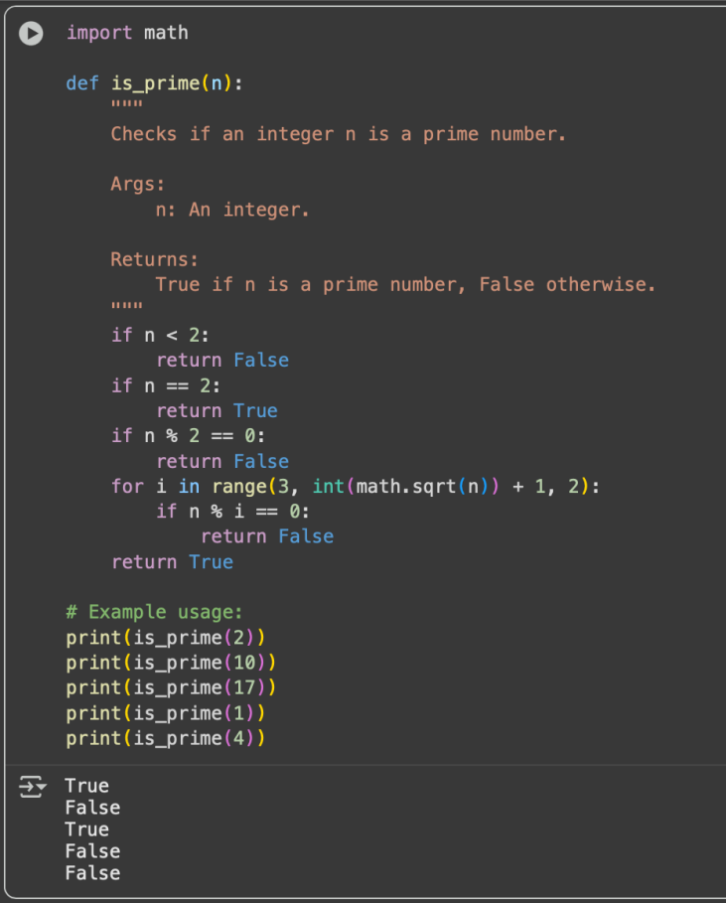

Task Description:#3

Write a comment like #Function to reverse a string and use Copilot to generate function

Expected Output:

Auto-completed reverse function

Prompt1: Write a python function where it take string as an input and revers the string.

Code:

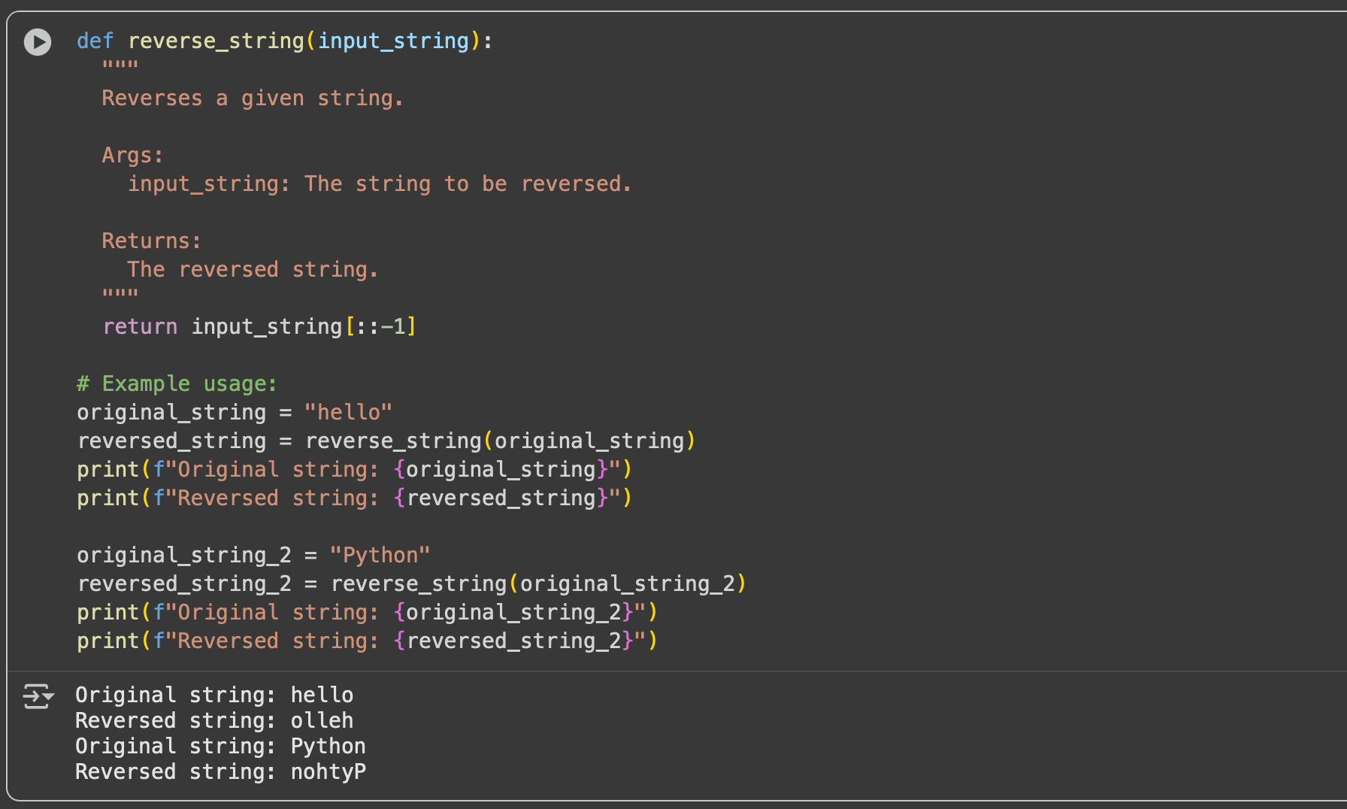

Task Description#4:

Generate both recursive and iterative versions of a factorial function using comments

Excepted Output:

Two working factorial implementations

Prompt 1:

Generate two Python functions to calculate the factorial of a number:

1. A recursive version.

2. An iterative version (using a loop).

include comments in both functions to explain the logic.

Code:

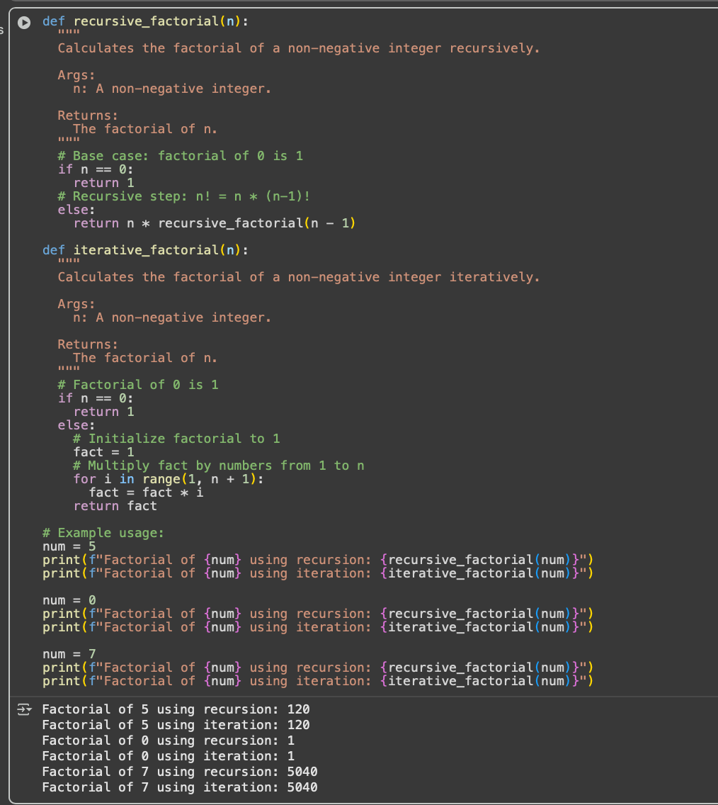

120

Task Description #5:

Use copilot to find the largest number in a list.Assess code quality and efficiency

Expected Output:

A valid function with your review

Prompt 1:

Write a Python function called find_max that takes a list of numbers as its input and returns the largest number in that list.

Code:

